MAC Block Automation Tool
Use Case :
Using this tool user can add the library components (FB, FC, DB, etc.) to the TIA Portal project and provide a user interface that allows users to define and update the block calling structure and interface tags for the called blocks. Additionally, it enables updating existing project for block calling and tag assignment.
Technology:
- C# (.NET Framework)
- Siemens TIA Portal Openness Version?
- WPF (UI)
- CSV + XML Processing
Purpose:
Instead of manually creating PLC logic networks in TIA, the user can:
- Define block calls in UI
- Generate CSV
- Automatically create networks and instance DBs in TIA
Project Structure :
Your solution contains the following major components:
GeneratedClasses
Auto-generated PLC block classes.
Examples:
Block_1.cs
Block_2.cs
TestLibrary.cs
These represent PLC blocks from the TIA library.

Core Logic Files
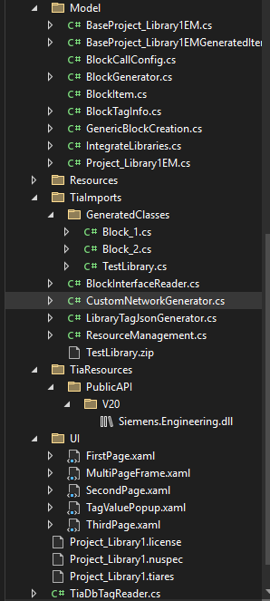
These files handle:
- Block interface reading
- Network generation
- JSON generation
- PLC resource integration
Flow of Project :
- Needs to create PLC logic like:
- OB (Main program)
- FC (Function call)
- FB (Function block with Instance DB)
- Tag connections
Normally, this is done manually in TIA Portal
- MAC tool allows:
  - In MAC Application user first create project based on TIA Portal then give path of. ap Project of TIA Project.
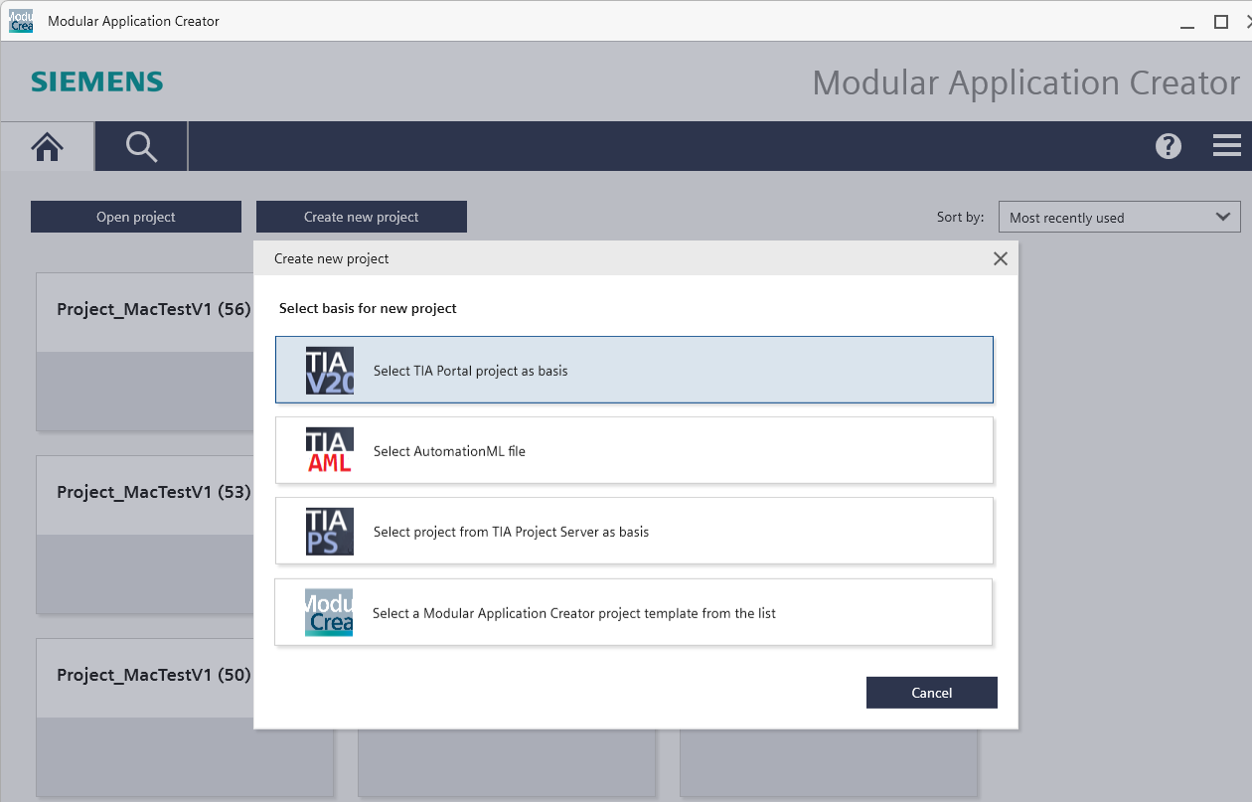
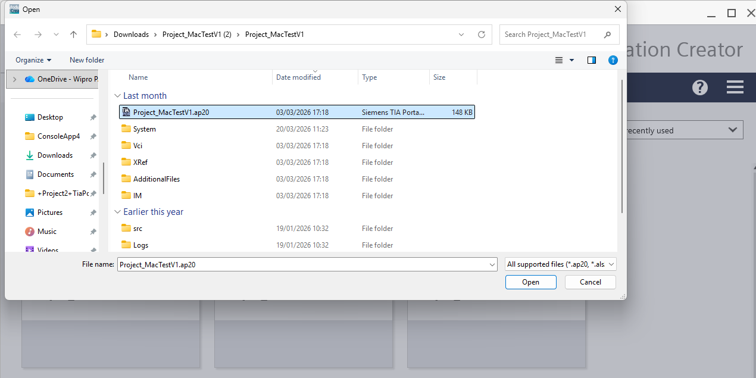
  - Then We will Drag and Drop Module on Select Modules Page, after successfully creating module, we select it and goes on next page which is Configure Modules.
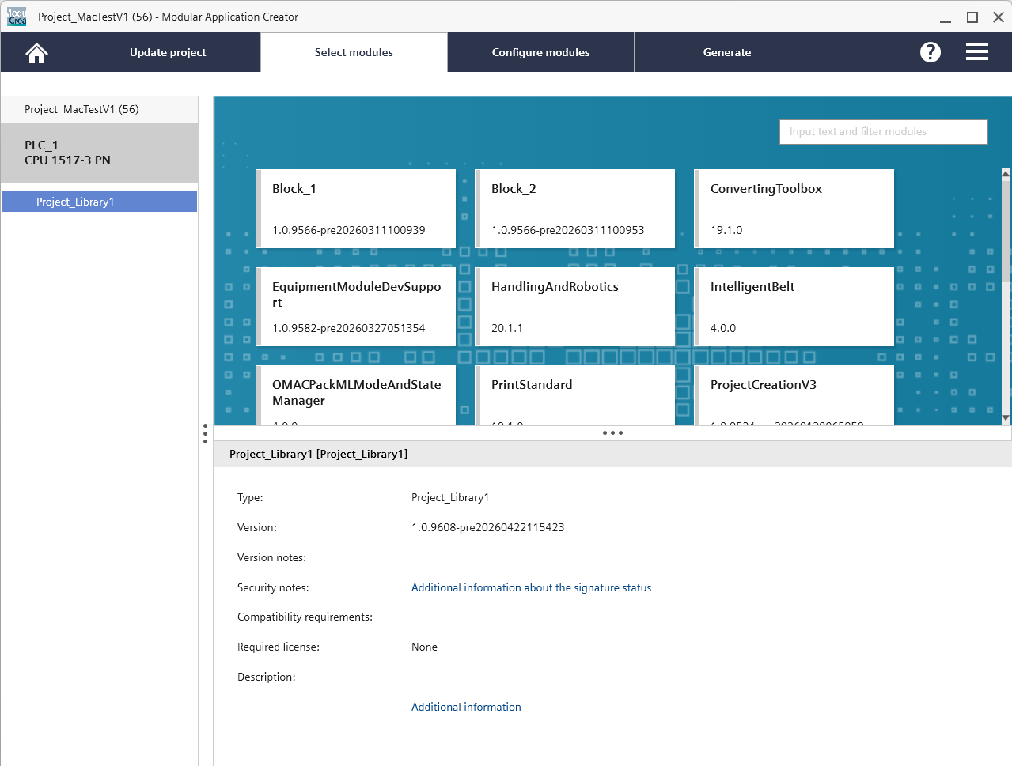
  - Three pages present on Configure Modules
First Page
Purpose:
Allows the user to select blocks from the TestLibrary_Blocks.
Features:
- Displays available PLC blocks
- User selects blocks for automation
- Selected blocks move to configuration stage
First Page – Add Library Blocks into TIA Project
Feature: Add Library Block into TIA Project
(Checkbox)
A checkbox option is provided on the First Page of the MAC tool to allow the user to control whether Add Library Block into TIA Project
Checkbox Label
Add Library Block into TIA Project(SkipBlock Calling)
Purpose of the Checkbox
This option enables a Add Library Block into TIA Project where the user can work with block configuration and tag mapping without generating PLC logic in TIA Portal.
This is useful for:
- Testing block interfaces
- Generating JSON configuration
- Validating tag assignments
- Demonstrating the tool without modifying the PLC project
Behavior of the Checkbox
When Checkbox is Checked
If the checkbox is enabled:
- The system does not execute PLC generation logic
- The following function is skipped:
GenerateOBWithMultipleCalls()
Instead, the tool operates only Add Library Block into TIA Project.
Allowed operations:
No changes are made to the TIA project.
Message shown:
Started Add Library Block into TIA Project.
Block Calling skipped.
When Checkbox is Unchecked
- The system runs the full MAC generation process.
- PLC program structures are automatically created inside TIA Portal.
The following actions occur:
- Read CSV configuration files
- Generate OB networks
- Create FB / FC block calls
- Create Instance Data Blocks
- Connect input/output tags
The main method executed:
GenerateOBWithMultipleCalls()
Result:
PLC logic is generated inside the TIA Portal project.
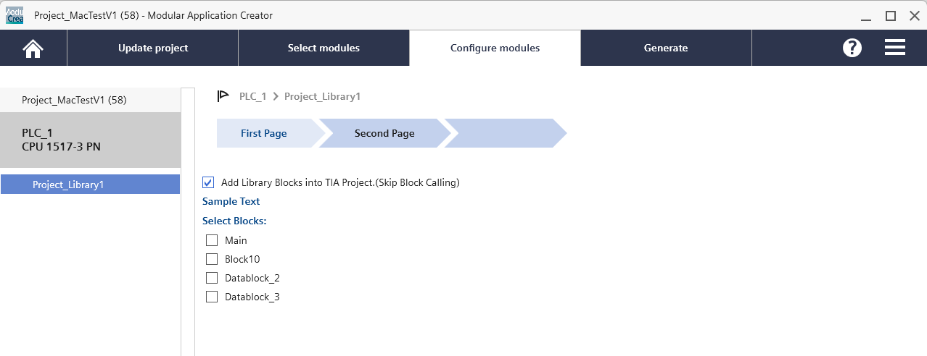
Second Page
Purpose:
Generates the BlockTags.json file.
Button:
Generate BlockTags.json
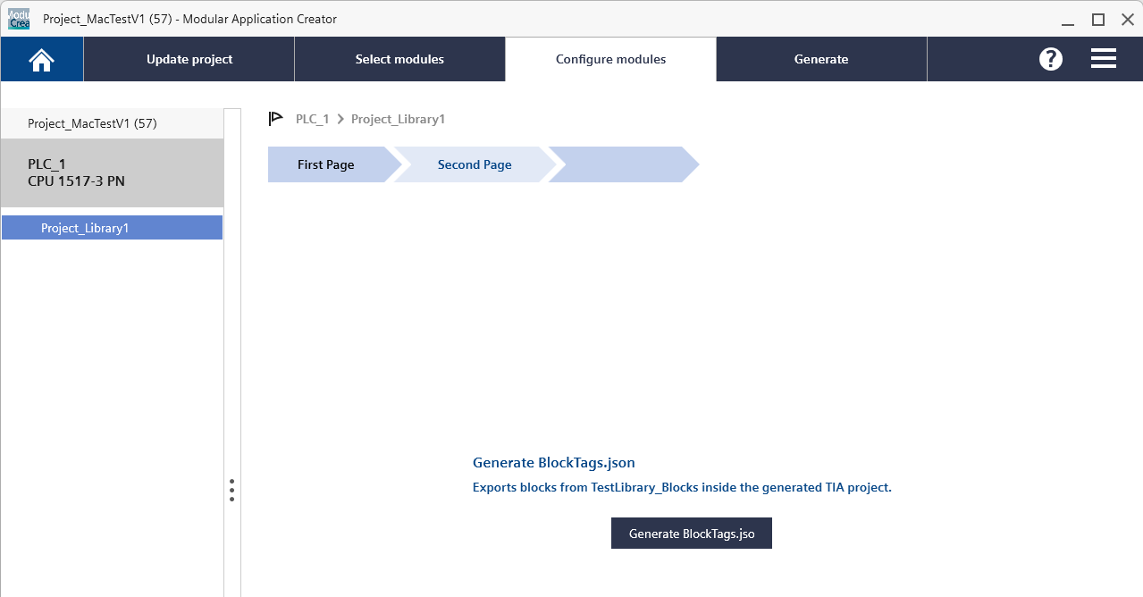
Functionality:
Example JSON:
{
"Block_1": {
"Inputs": {
"Input1": "Int",
"Input2": "Int"
},
"Outputs": {
"Output1": "Int",
"Output2": "Int"
}
}
}

The system reads block interfaces from the TIA project and exports them into a JSON structure.
Purpose of JSON:
- Stores block interface structure
- Used later to validate tags
- Provides datatype mapping
Output file:
C:\MACOP\Export\BlockTags.json
Third Page
Purpose:
Create the block call structure.
Features:
- TreeView block structure
- Parent-child block relationships
- Network number configuration
- Instance DB assignment

Example structure:
Main OB
└ DummyFC
├ Block_1 (Network 1)
├ Block_2 (Network 3)
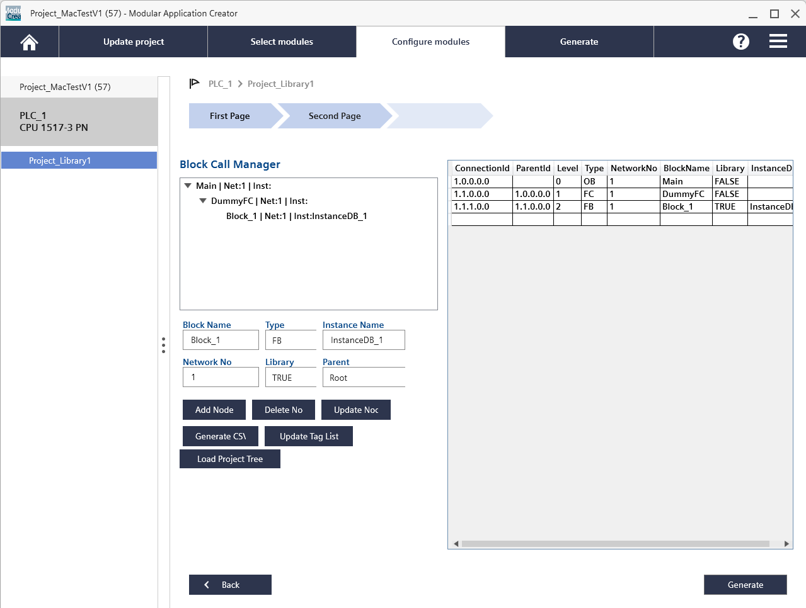
TagValuePopup Page
Purpose:
Allows the user to assign actual PLC tag values to block parameters.
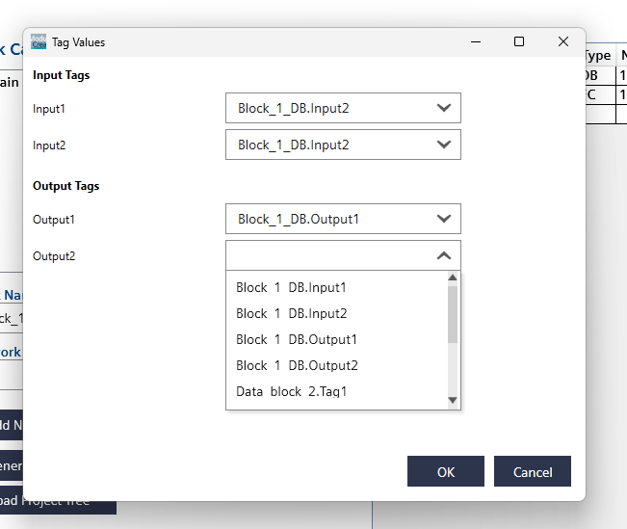
Connection ID Logic
Connection IDs represent hierarchy.
Example:
1.3.8.0.0
Meaning:
1 → OB network
3 → FC network
8 → FB network
0 → reserved
0 → reserved
This ensures proper block hierarchy generation.
CSV Generation
Once configuration is completed, click on Generate CSV button the tool generates CSV files.
ProgramBlock.csv
Defines program hierarchy.
Example:
ConnectionId,BlockName,InstanceDB
1.0.0.0.0,Main,
1.1.0.0.0,DummyFC,
1.1.1.0.0,Block_1,InstanceDB_1
Interface.csv
Defines connections.
Example:
ConnectionId,BlockName,InstanceDB,InputTag,OutputTag
1.1.1.0.0,Block_1,InstanceDB_1,Data_block_2.Tag1,Data_block_3.Output1
Generation Engine
Main method:
GenerateOBWithMultipleCalls()
Responsibilities:
- Read CSV files
- Parse block hierarchy
- Create PLC networks
- Create instance DBs
- Connect input/output tags
TIA Portal Automation
Using TIA Portal Openness API, the system performs:
- OB creation
- Network creation according to user Provided Network Number
- FB / FC calls
- Instance DB creation
- Tag connections

Result in TIA Portal:
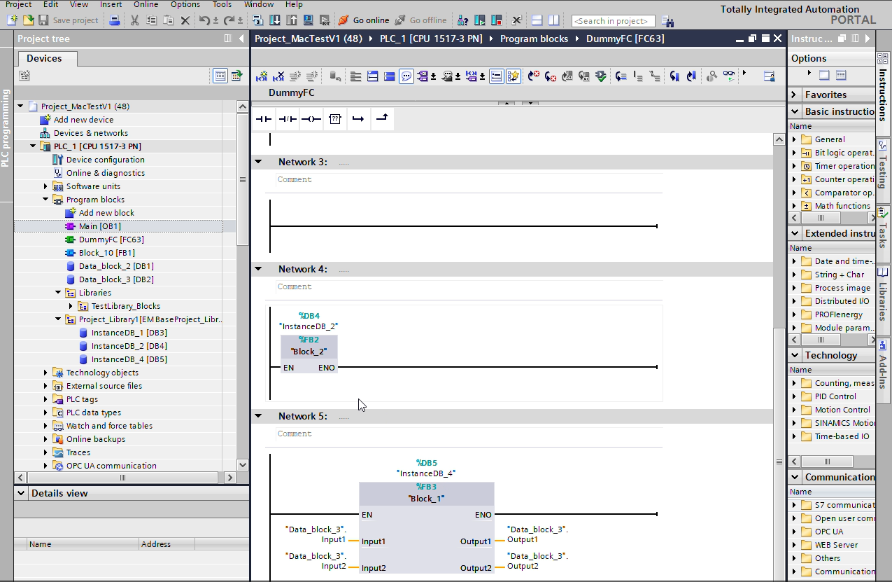

All Methods Used in C # Programming with Descriptions
First Page – Block Selection Page
Mention Class .cs
Method: ChkTestLibrary_Checked()
Purpose
It will Add Test Library in TIA Project and skip Block Calling.
Function
Sets SkipTiaGeneration = true
Method: ChkTestLibrary_Unchecked()
Purpose
Generate TIA Project With Block Calling Based on Test Library Blocks.
Function
Sets SkipTiaGeneration = false
Second Page – Generate Block Interface JSON
Purpose
Exports block interfaces from TestLibrary_Blocks and generates a JSON file containing:
- Block name
- Input parameters
- Output parameters
- Data types
Button: Generate BlockTags.json
Purpose
Reads block interfaces from the library and exports them into a JSON file.
Output File
C:\MACOP\Export\BlockTags.json
Method: LibraryTagJsonGenerator.Generate()
Purpose
Generates the BlockTags.json file.
Description
Steps performed:
- Reads blocks from TestLibrary_Blocks
- Extracts interface parameters
- Reads datatype information
- Builds JSON structure
- Writes JSON file

Example JSON Structure
{
"Block_1": {
"Inputs": {
"Input1": "Int",
"Input2": "Int"
},
"Outputs": {
"Output1": "Int",
"Output2": "Int"
}
}
}
Third Page – Block Call Manager
Purpose
Allows the user to build the PLC block call structure.
This page contains:
- TreeView block hierarchy
- Table showing connection IDs
- Block configuration controls
Button: Add Node
Purpose
Adds a new block to the Tree structure if this block has Input and Output tags then it will open popup to provide values.
Method
Mention Class .cs
AddNode_Click()
Description
Creates a new node in the TreeView containing:
- Block name
- Network number
- Instance DB
- Parent block
TagValuePopup – Assign Input/Output Tags
Purpose
Allows the user to assign actual PLC tag values to block inputs and outputs.
Method: OpenTagValuePopup()
Purpose
Opens the popup window for tag assignment.
Method: SaveTagValues()
Purpose
Stores assigned tag values.
Stored Data
Dictionary<string,string> InputTags
Dictionary<string,string> OutputTags
Example
Input1 → Data_block_2.Tag1
Input2 → Data_block_2.Tag2
Output1 → Data_block_3.Output1
Button: Delete Node
Method
DeleteNode_Click()
Purpose
Removes the selected block from the TreeView.
Button: Update Node
Method
UpdateNode_Click()
Purpose
Updates block properties such as:
- Block Name
- Network Number
- Instance DB
Button: Update Tag List
Mention Class .cs
Method
UpdateTagList_Click()
Purpose
Opens TagValuePopup to update tag assignments.
Button: Generate CSV
Method
GenerateCSV_Click()
Purpose
Generates CSV files used for PLC generation.
CSV Files Generated
ProgramBlock.csv
Contains block hierarchy.
Example
ConnectionId,BlockName,InstanceDB
1.0.0.0.0,Main,
1.1.0.0.0,DummyFC,
1.1.1.0.0,Block_1,InstanceDB_1
Interface.csv
Contains tag connections.
Example
ConnectionId,InputTag,OutputTag
1.1.1.0.0,Data_block_2.Tag1,Data_block_3.Output1
FlatTable.csv
Used internally for network parsing.
Method: GenerateTableFromTree()
Purpose
Converts the Tree structure into a flat table.
Mention Class .cs
Processes:
- Parent-child hierarchy
- Network numbers
- Connection IDs
Method: BuildFlatRowsRec()
Purpose
Generates hierarchical connection IDs.
Example
1.3.8.0.0
Meaning
OB Network → FC Network → FB Network
MAC Generation Engine
Main Method
GenerateOBWithMultipleCalls()
Purpose
Creates PLC program structure in TIA Portal.

Internal Steps
Step 1
Read CSV files
ProgramBlock.csv
Interface.csv

Step 2
Parse block hierarchy
Methods used
Mention Class .cs
Program.ReadMainObData()
Program.ReadBlockData()
Program.ReadAllConnectionData()

Step 3
Create Instance DBs
IntegrateLibraries.CreateInstanceDataBlock()

Step 4
Generate OB Networks
CustomNetworkGenerator.Generate()

Step 5
Create FB / FC Calls
Blocks are placed in the generated networks.

Step 6
Connect Tags
Input/output tags are connected using the data from Interface.csv.

6TIA Portal Automation
Using TIA Portal Openness API, the system performs:
- OB network creation
- FB / FC calls
- Instance DB generation
- Tag connections

FLOW CHART OF MAC APPLICATION
Start

Is Checkbox Clicked?
Select Module (Drag and Drop)
Launch MAC Application

On First Page Add Library Blocks in TIA Project(Skip Block Calling) & For First time we need to Tick on Checkbox to show Library Blocks on First Page it is Mandatory.

NO YES
End
Then Click On Generate button in MAC Application then MAC Reads generated Interface & Program Block CSV Files, Using TIA Portal Openness it Generate Networks & DBs & PLC Program Created

On Third Page ThirdPage Create Block Call Structure, and Click On Generate CSV Button,It will generate Interface & Program Block CSV files.

On Second Page Click on Generate BlockTags.json to create Tags Json File. To Assign Input/Output Tags in TagValuePopup .

On First Page Select Blocks which want to call in TIA Project

End
Then Automatically Opens TIA Project with added library in it. Then user need to close Tia & Click on Update button in MAC after this Test Library Blocks will show on First Page.
It Adds Library in TIA Project Without Block Calling
Click On Generate Button in MAC Application

Mention Section/UI Part

